Report

In recent years, both City Hotel and Resort Hotel have encountered significant challenges stemming from high cancellation rates, leading to a range of issues such as decreased revenue and suboptimal utilization of hotel rooms. Consequently, the primary objective for both hotels is to reduce cancellation rates to enhance revenue generation efficiency. Our focus lies in analysing hotel booking cancellations along with relevant factors impacting business performance and annual revenue.

ASSUMPTION:

- Assumption of Stability: It is assumed that no significant unforeseen events occurred between 2015 and 2017 that would substantially affect the data under analysis.

- Relevance of Current Information: The data remains current and relevant for efficient analysis and strategic planning regarding hotel operations.

- Absence of Unexpected Drawbacks: There are no unanticipated negative consequences anticipated from implementing recommended strategies for the hotel.

- Non-Utilization of Proposed Solutions: The hotel is not currently employing any of the suggested solutions to address booking cancellations

- Primary Impact of Cancellations on Revenue: The most significant factor influencing potential revenue loss is attributed to cancellations of bookings.

- Impact of Cancellations on Room Utilization: Cancellations result in rooms remaining vacant for the duration of the originally booked stay.

- Timeliness of Reservation and Cancellation: Clients typically make hotel reservations and cancellations within the same calendar year.

Research Questions:

- What are the key variables influencing the cancellation of hotel reservations?

- How can the process of handling hotel reservation cancellations be optimized?

- In what ways can hotels be supported in making informed decisions regarding pricing and promotions?

Hypothesis:

- Higher prices are associated with an increase in reservation cancellations.

- Increased waiting list duration correlates with higher cancellation rates among customers.

- A significant proportion of clients prefer making their reservations through offline travel agents.

Analysis & Findings:

The bar graph illustrates the percentage of reservations that have been cancelled compared to those that have not. It is evident that a substantial portion of reservations remain unaffected by cancellations. However, 37% of clients have cancelled their reservations, highlighting a notable impact on the earnings of hotels.

City hotels tend to receive more bookings compared to resort hotels, possibly due to the latter's higher pricing. Specifically, resort hotels had 28,519 bookings that were not cancelled and 11,077 that were cancelled. In contrast, city hotels had 46,226 bookings that were not cancelled and 33,076 that were cancelled.

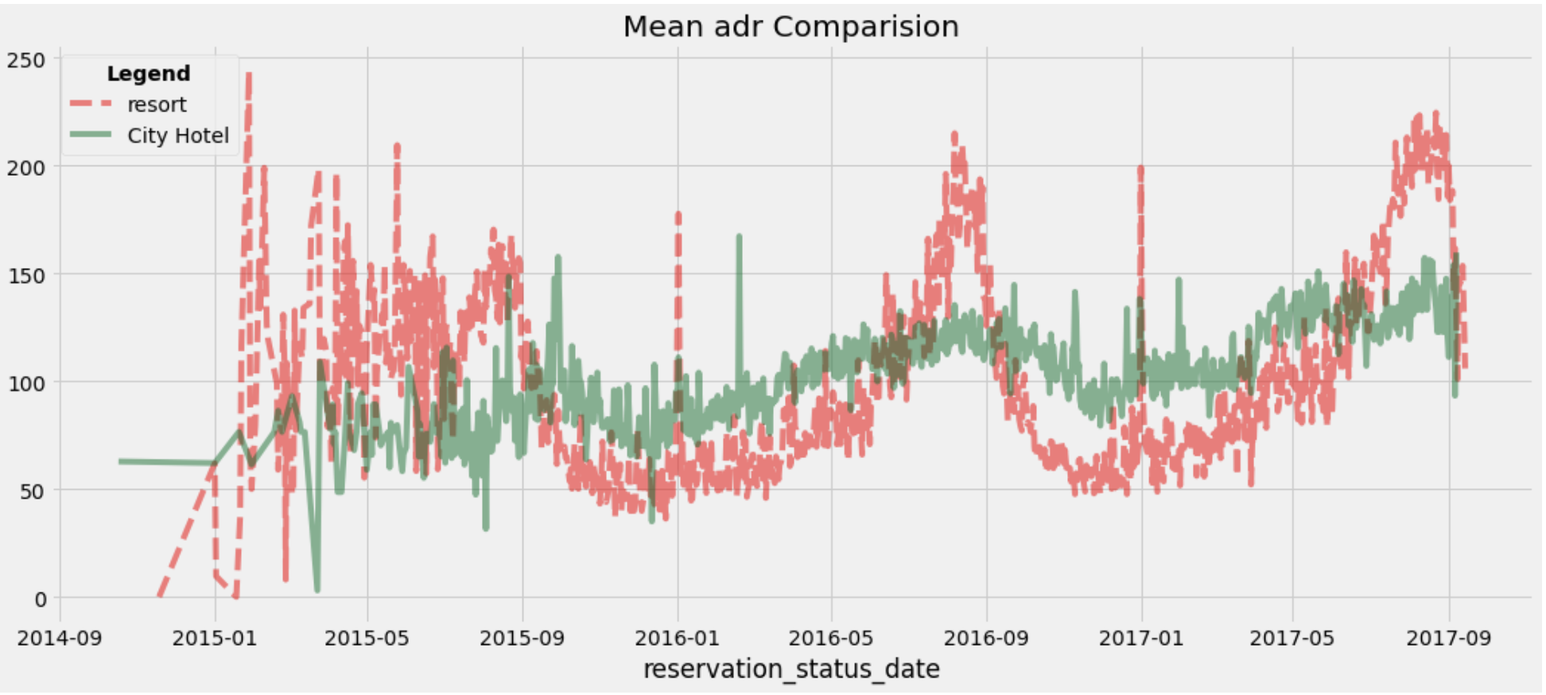

The above shows, resort hotel has been more expensive all through out barring, certain phases where the spike in city hotel’s price could be seen.

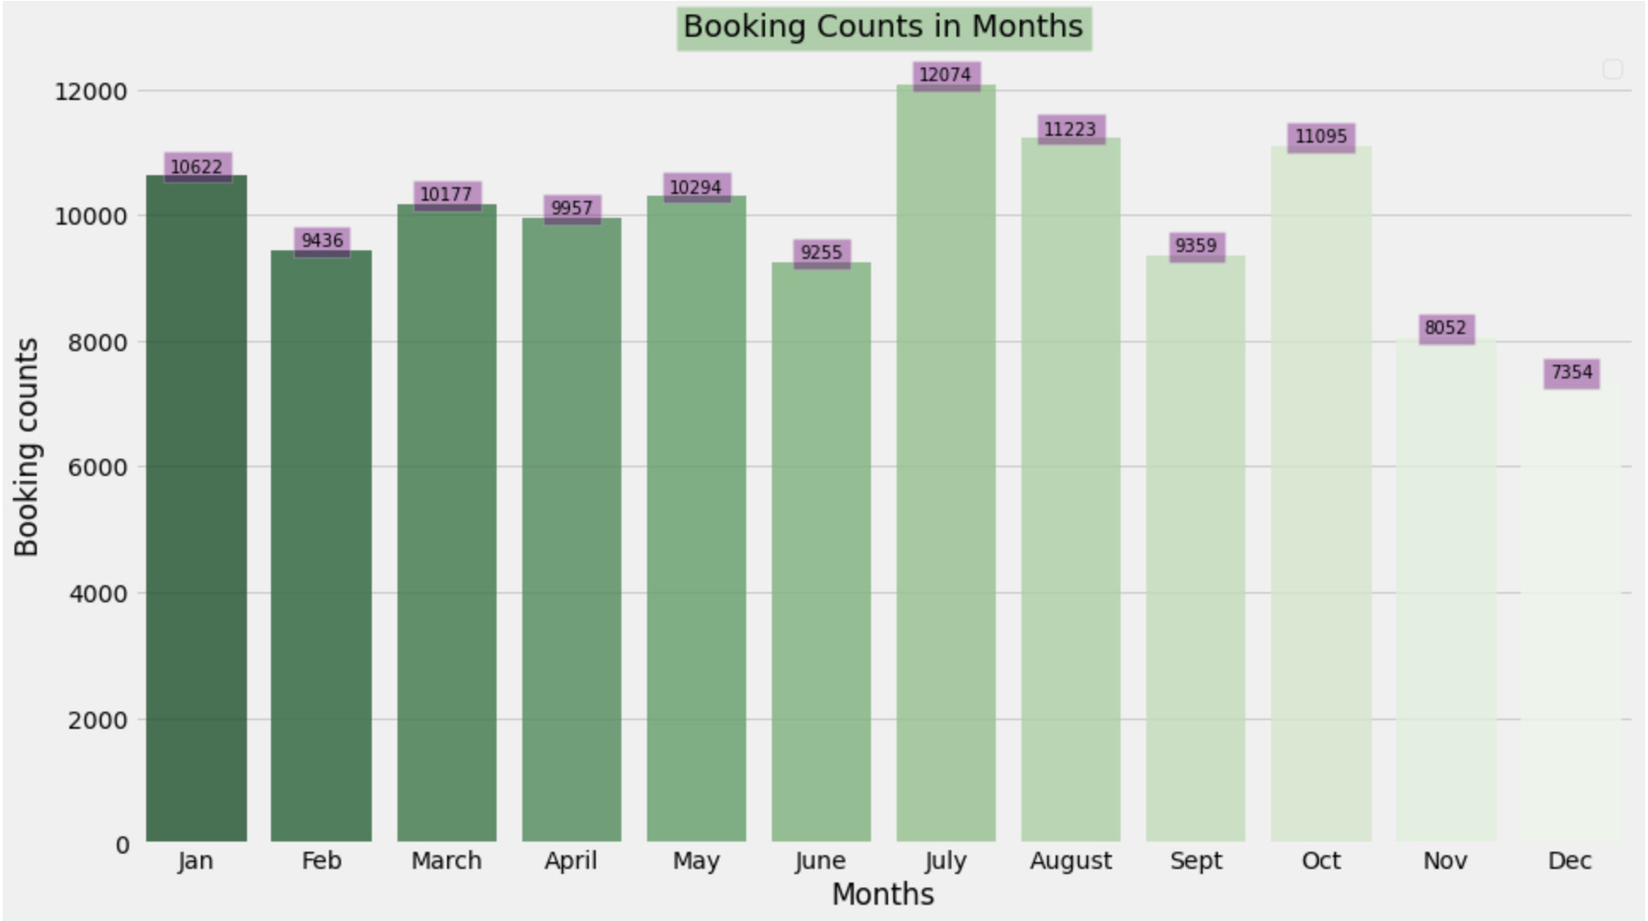

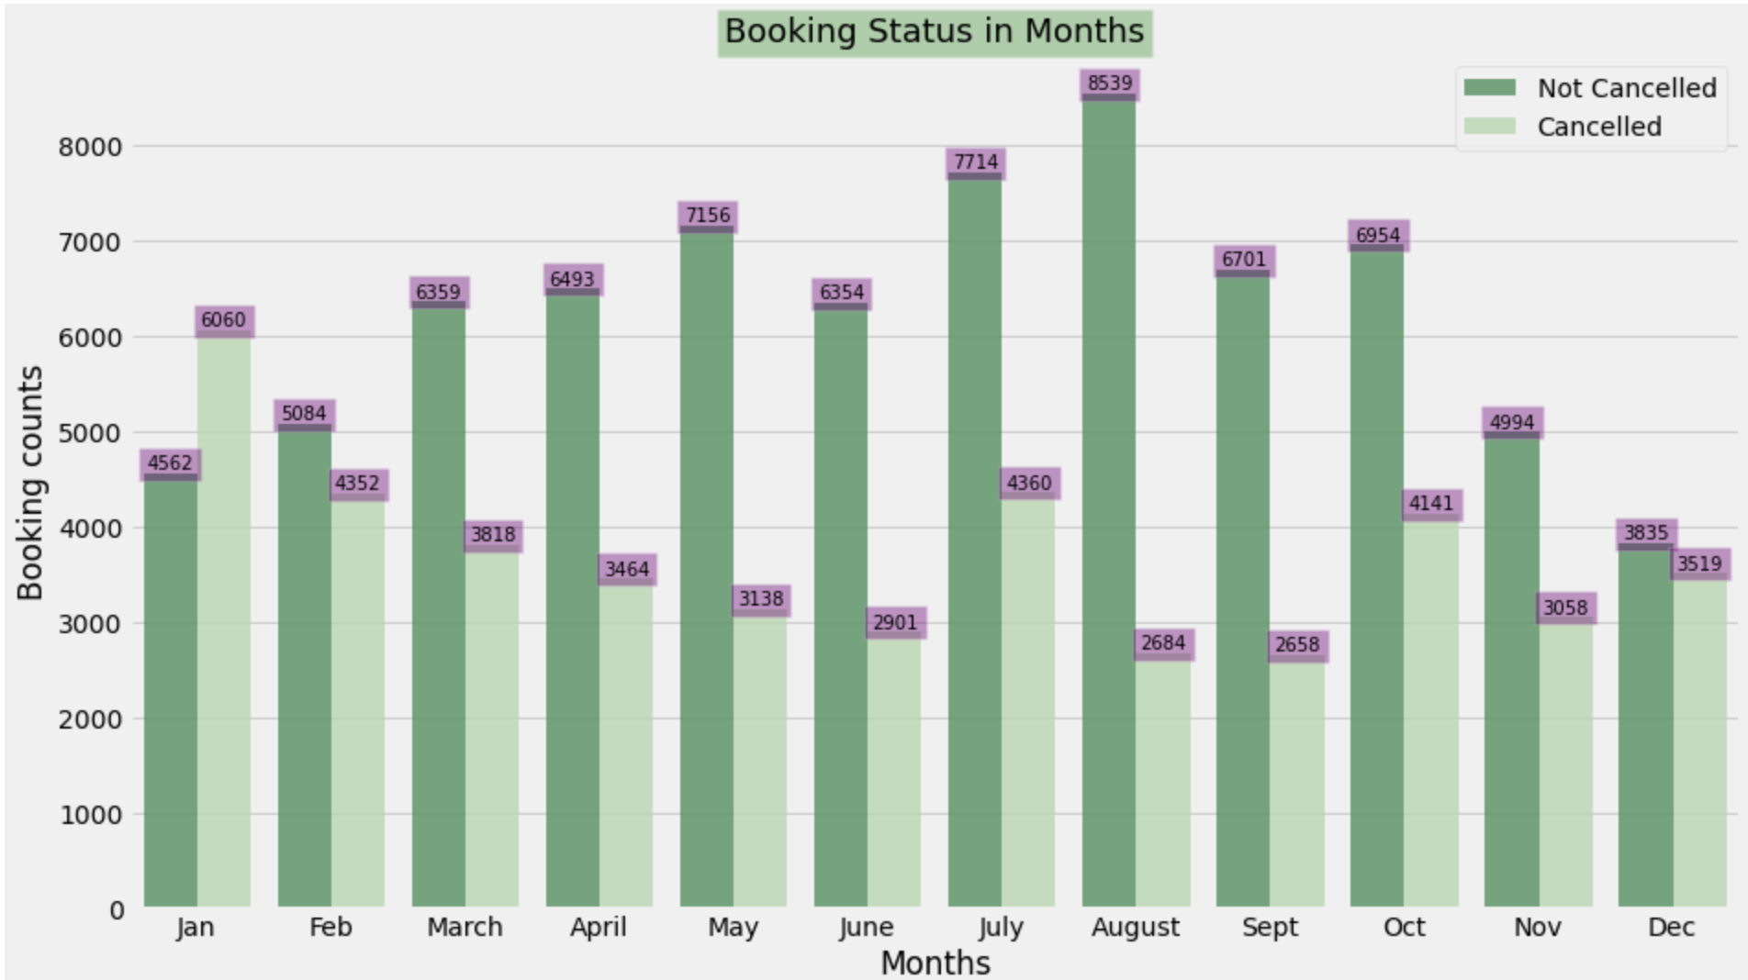

Maximum bookings have happened in the month of July, and so has the number  
 of cancellation.

Comparatively there is a spike in prices (adr) for both city hotel and resort in the Month of July followed by August.

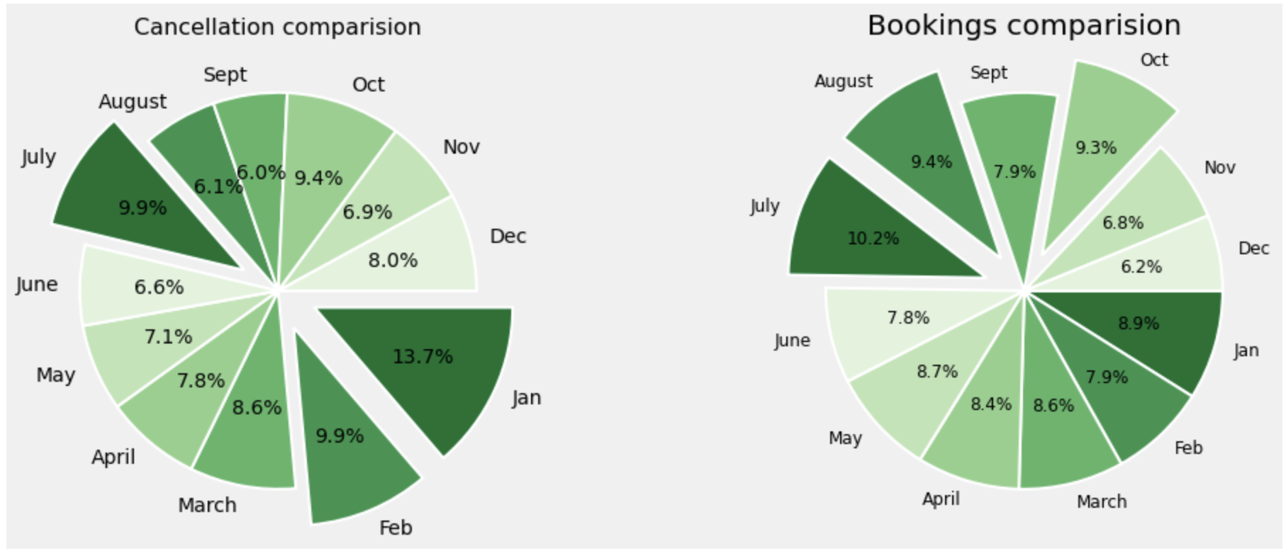

July, Aug and Oct cater to the maximum bookings, but Jan followed by July and Feb contribute to the cancellation rates.

We had assumed that it is owed to price.

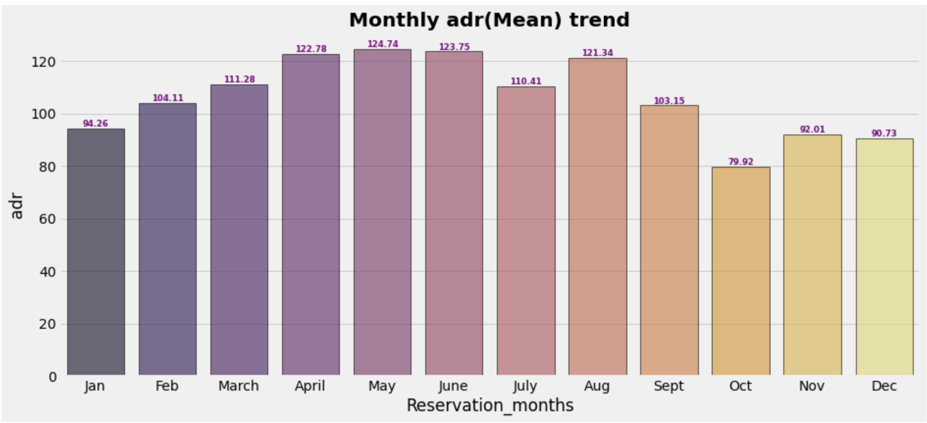

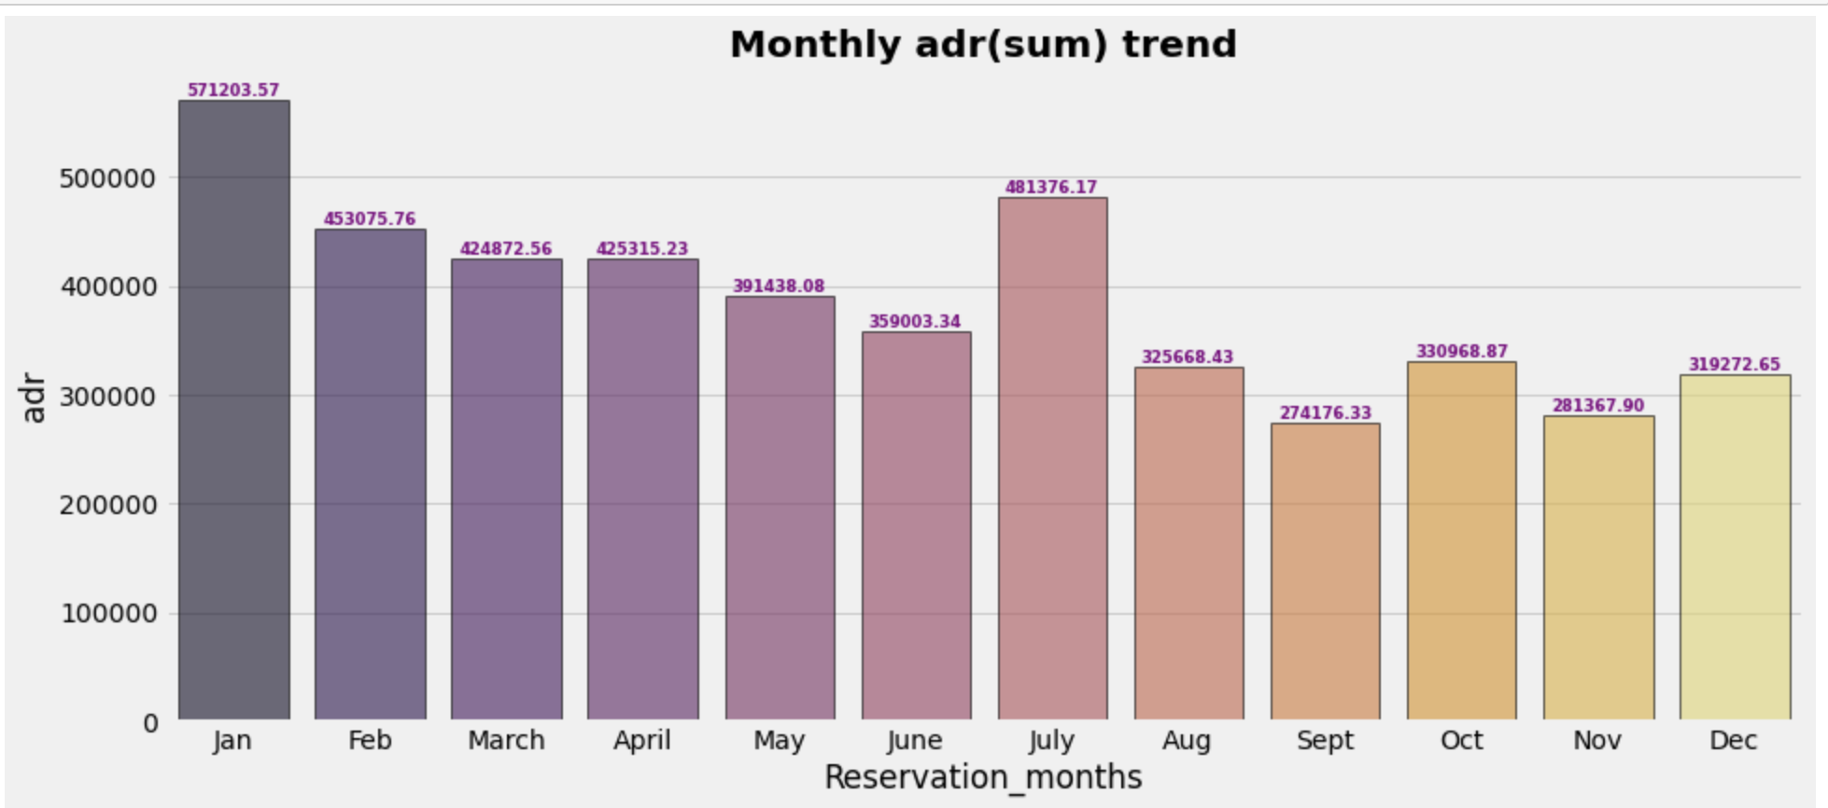

**Observation**:

- Cancellations: highest in Jan

- mean adr in jan is less but sum of adr in jan is more

- sugegst ; though cancellations have happened but overall revenue contribution,

- jan tops, might be because of longer stays or occupancies

- While ADR can influence cancellation rates to some extent (e.g., guests might cancel if they find a cheaper rate elsewhere),

- it's not the only factor at play.

- Other factors such as customer preferences, external events, and economic conditions can also influence

cancellation behavior.

**Seasonal Variation in Cancellation Rates:**

**- Highest Cancellation Months:**

- January, July, and October stand out with relatively high cancellation rates

(13.7%, 9.9%, and 9.4% respectively).

- These months show spikes compared to others, indicating potential seasonal factors

influencing cancellation behavior.

- **Lowest Cancellation Months:**

- November and December have the lowest cancellation rates (6.9% and 8.0% respectively),

which could suggest more stable booking patterns possibly due to holidays or special events.

**Comparison with Booking Rates:**

- **Misalignment in July:**

- July has a high cancellation rate (9.9%) despite having a high booking rate (10.2%).

- This discrepancy warrants investigation into what factors might be causing customers to cancel bookings during this typically busy period.

**Average Daily Rate (ADR) Impact:**

**- Inverse Relationship:**

- Generally, months with higher ADRs tend to have lower cancellation rates.

- For example, months like April and May, which have higher ADRs (122.78 and 124.74 respectively) correspondingly have lower cancellation rates (7.8% and 7.1% respectively).

- This suggests that customers may be more committed to bookings when they have already made a higher financial commitment.

**Economic and Seasonal Influences:**

- **October Anomaly:**

- October stands out with a high cancellation rate (9.4%) despite having a relatively low ADR.

- This could indicate specific economic factors or events influencing booking decisions in that month.

Thus, cancellations, being owed only to higher prices or lower prices, that assumption was proven to be wrong. There are other factors which influence.

Let’s check the source of bookings.

The assumption that, majority bookings happened through offline TAs was again proven to be wrong, for, from the analysis, it was through online Travel Agents followed by offline.

Online Cancellations were the highest at 46.96 % followed by the ones booked in groups 27.39 % and 18.74 % for offline.

Thus, cancellation rates are relatively lower for the tickets booked offline.

Now, let's see which country has the highest reservation canceled. The top country is Portugal with the highest number of cancellations

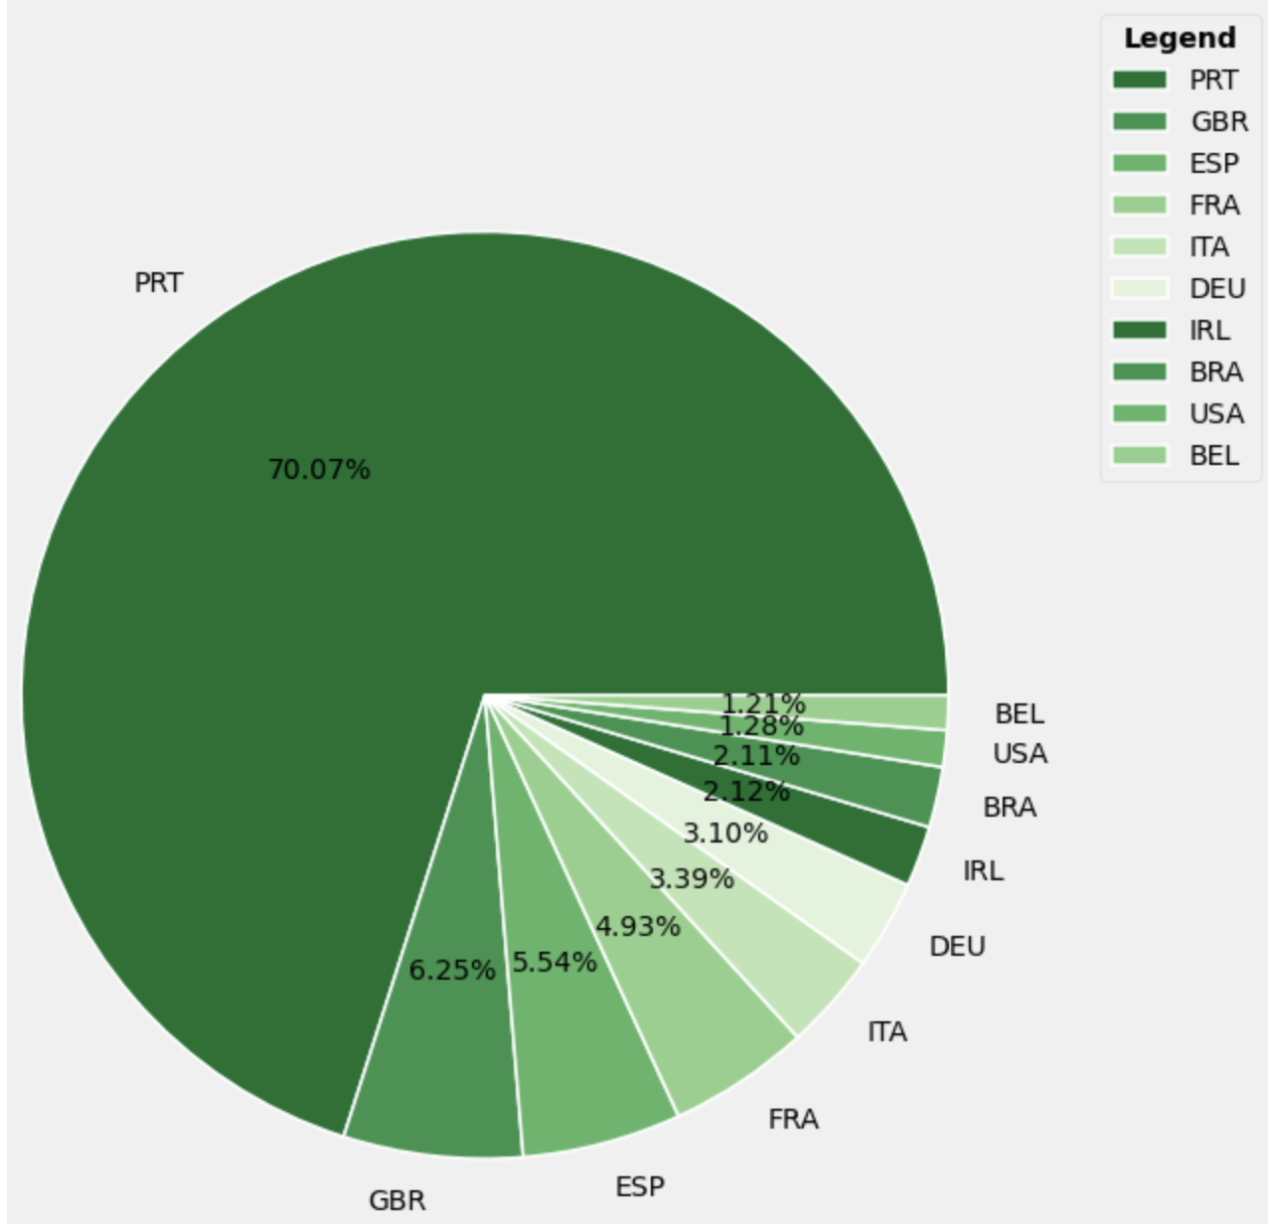

Suggestions:

* To mitigate reservation cancellations, hotels could refine their pricing strategies by offering targeted discounts based on specific locations, thereby potentially lowering cancellation rates.
* Given the higher cancellation-to-booking ratio observed in resort hotels compared to city hotels, it would be beneficial for hotels to consider offering competitive weekend and holiday discounts on room rates.
* In January, hotels can initiate marketing campaigns with attractive incentives to bolster revenue, recognizing that cancellation rates tend to peak during this month.
* Enhancing hotel quality and service standards, particularly in Portugal, could be effective in reducing cancellation rates and improving overall guest satisfaction.